User Manual

The following User Manual will explain in detail how to use the Sydney Stayz Airbnb data analysis tool. The Manual will feature images with a step-by-step process on how the analysis tool works. Any date range inputs are only to be specified throughout 2019 as this is the current data we’re working with. Please be advised this is a work in progress product and some features may take time to load.

In the CSV directory calendary_dec18.csv, listings_dec18.csv and reviews_dec18.csv need to be added

The following python packages also need to be installed on your environment:

* pandas
* tkcalendar
* wxPython
* Matplotlib

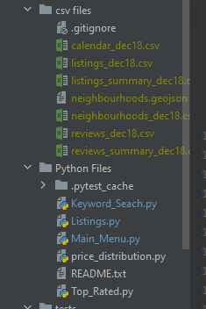 File layout in python

Main Menu:

From the Main Menu, user can navigate to the component they wish to pull data from. In doing so, the user will be prompted to a separate page which will feature the required tools the user will need to retrieve Sydney Airbnb data. The Main Menu features the following component buttons (see fig 1.0):

* Listings
* Top Rated
* Price Distribution
* Keyword Search

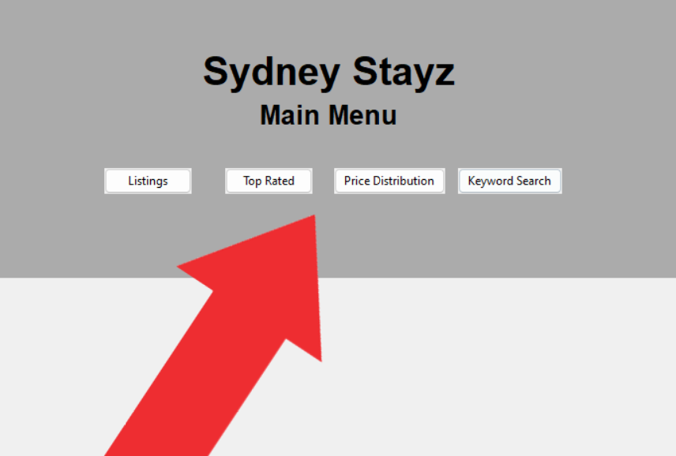

feature button selections. Fig 1.0

Below is the zoomed out version of the main menu.

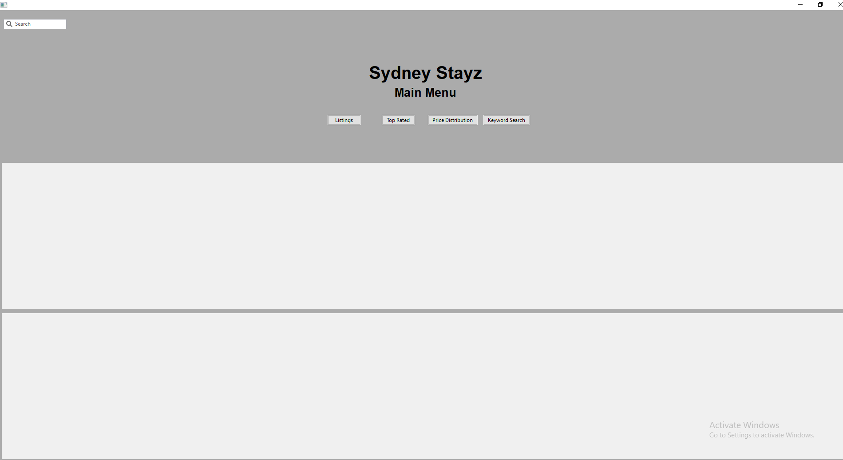

Listings:

From the main menu, user can select the Listings button which will display a listings page. Following the listings page being displayed, a popup table that allows users to select a neighbourhood from Sydney, a property type (optional) and a date range widget to refine their search.

The table also features a Cleanliness Comment Analyser feature which will find and display the customer comments from the properties based on the refined property search results displayed under the listings table, this allows users to scroll through and see visitor comments. The Listing ID in both tables shows which property they’re commenting on. The table shows information on the Name of the property, the neighbourhood, the property type, the price to stay at the property per night and the date the listing was added. Additionally, user can double click the listing URL for the Airbnb listing to open in a browser. see fig 2.0 for informative visual instructions on generating listings table and cleanliness comment table. See 3.0 for generated cleanliness comment table

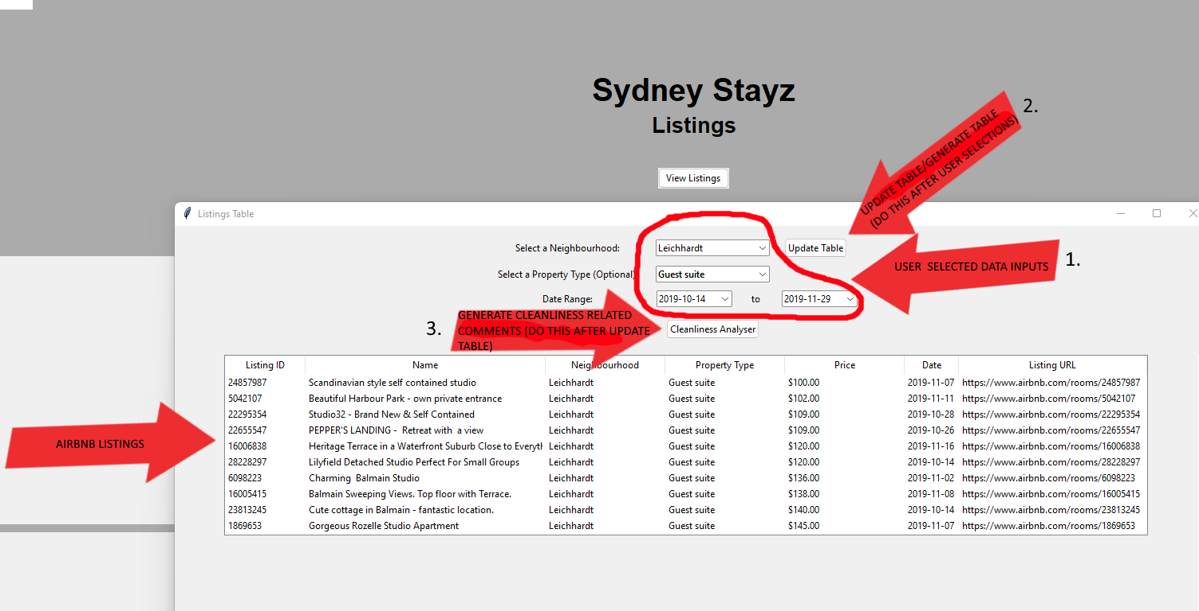Fig 2.0 Listings visual instructions

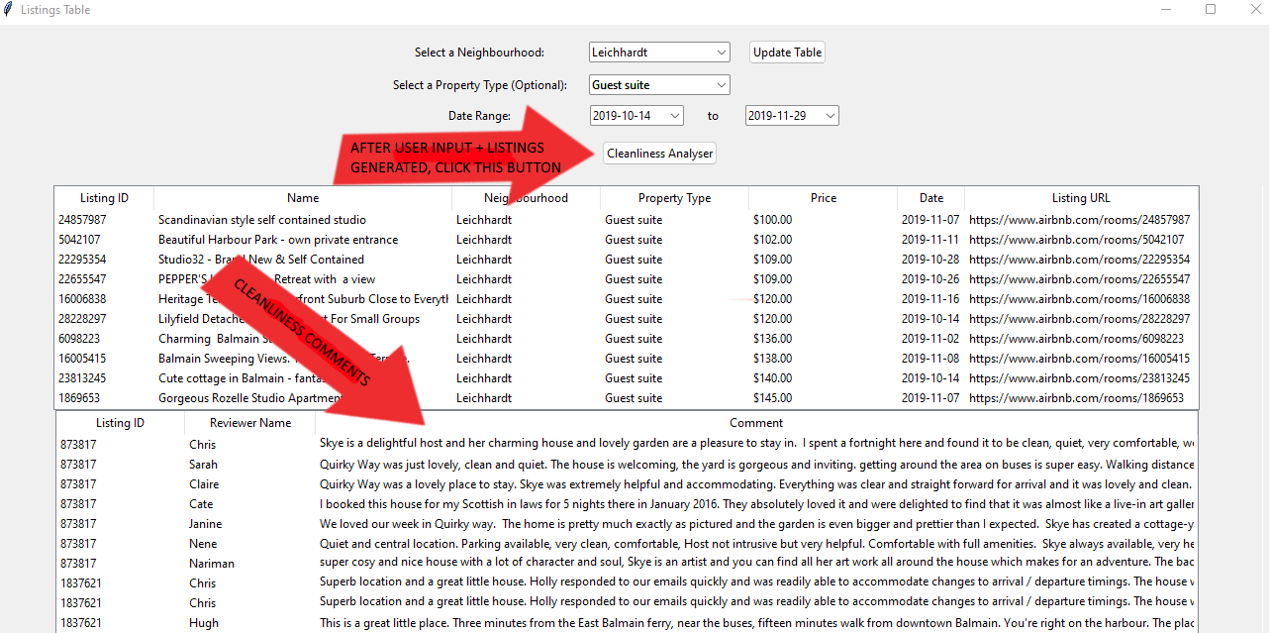Fig 3.0 Generated cleanliness comment table

Once finished viewing these results, a user may close the popup and hit the “back to main menu” button to go back and make a new feature selection. Below and a zoomed-out image of what the user will see with listings page and popup.

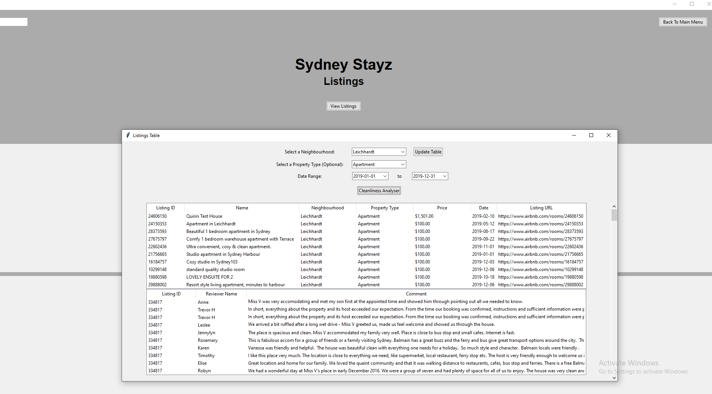

Top Rated:

From the main menu a user can navigate to the top rated page, which displays a popup window where users can select a Sydney Neighbourhood and (optional) property type, and it will display a table with the best rated properties of that location and type. The generated table displays the Property Name, Neighbourhood, Property type, the average review score and a link to the Airbnb listing. Additionally, the users may filter the table to show listings specified between a date range. See Fig 4.0 for a visual step-by-step on using the feature.

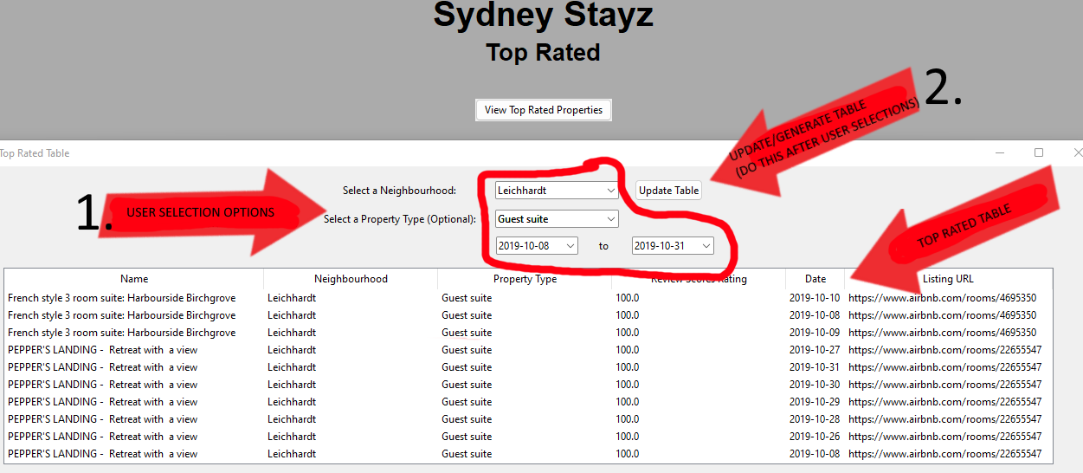

Fig 4.0 visual Top-rated instructions

Users can then close the popup and click the “back to main menu” button to use other features. In the below image, user has filtered listings to show In the Leichhardt neighbourhood for property type Townhouse and between the date ranges 2019-01-01 to 2019-12-31. The filtered listings are displayed from highest review score rating to lowest. See zoomed-out visual for the top-rated page below.

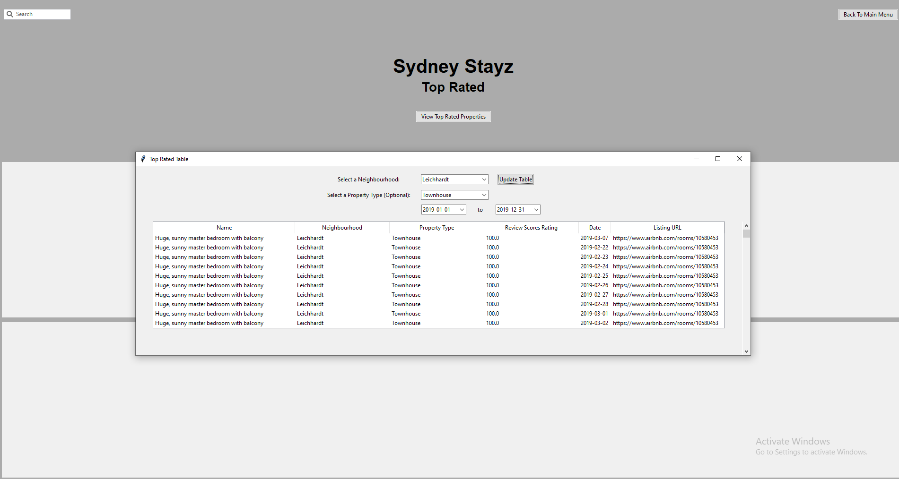

Price Distribution Chart:

From the main menu, users can select the “Price Distribution” button and be greeted by a new page which prompts users for some inputs, suburb 1 and suburb 2, a minimum and maximum value input and a start and end date range, See fig5.0. These selections will generate a graph comparing two different suburbs within the property price range input and date range.

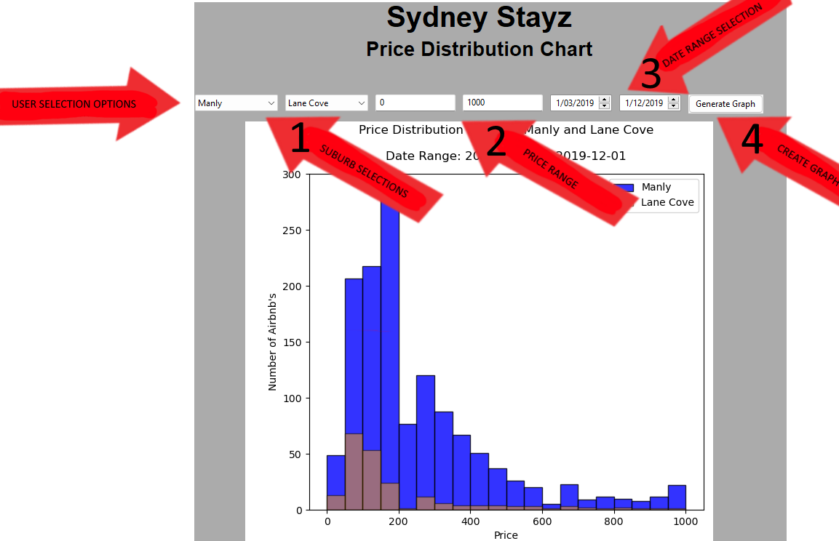Fig 5.0 graph inputs

The price distribution will be between the first two suburbs selected. The min and max value will filter data to show listings only between the specified price range, and finally the date range widget will specify listings to be shown between a specified date range. When the graph is generated, the x variable will represent “price” and the y variable will represent “number of Airbnb’s”. This graph will give users insights into the price differences in the area and time of year. Users can then hit the “back to main menu” button to make a new feature selection. The zoomed-out graph is seen below.

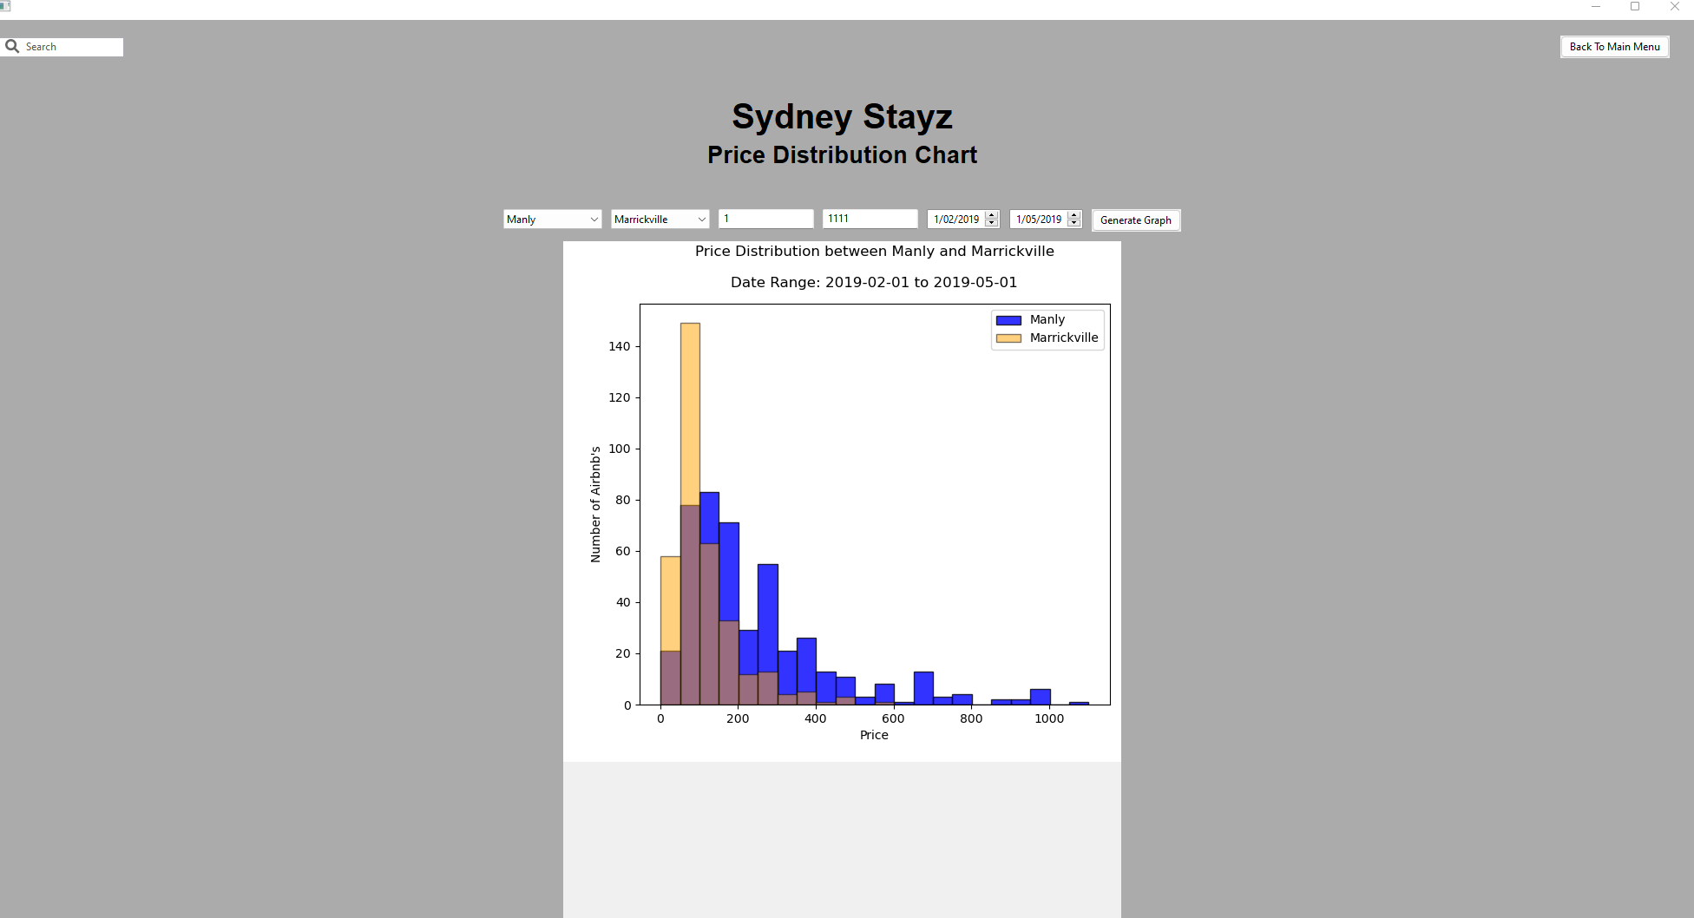

Keyword search:

The keyword search feature will allow users to select a date range and input a keyword before confirming to display a generated table. This table will show only the available listings for the date range and the properties which have that amenity. The information displayed will show the listing id, the name of the property, the availability the price per night and a small list of some of the amenities the listing offers. See fig 6.0 for visual instructions for use.

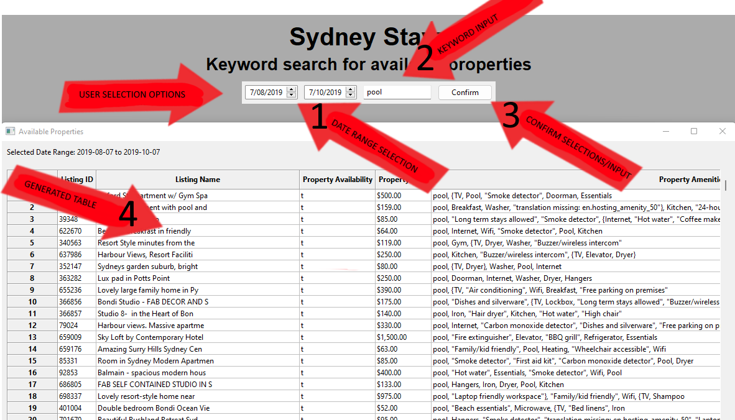

fig 6.0 keyword search

Below is the full zoomed-out page that users will see when using the keyword search function.

